SECURE MAIL SCOPE
SMART INDIA HACKATHON 2026
AI-Assisted Cryptographic Security Posture Assessment for Secure Email Communications
SIH26159
01 — THE STATEMENT
Problem Statement Description
Enterprise email runs on SMTP, IMAP and POP3. TLS is assumed to protect it. In practice they carry deprecated protocols, weak cipher suites, unvalidated certificates and stripped STARTTLS sessions, exposing organizations to downgrade, interception and man-in-the-middle attacks.
Build a passive forensic framework that ingests captured traffic, reconstructs sessions and TLS handshakes, validates X.509 certificates, and applies AI/ML to score risk, detect anomalies and prioritize remediation.

02 — THE REAL PROBLEM
Lack of Observability
TLS 1.3, ECDHE, MTA-STS and ACME already solve every technical weakness listed. Nothing needs inventing. The failure is observability.
Email faults are silent. Stripping STARTTLS and the mail is still delivered. Serves still accept expired certificates.
For example, HTTPS was fixed because browsers increased failure visibility. Email MUAs are unlike browsers, no enforcement chokepoint and no feedback loop, so misconfiguration increases,

03 — PROBLEM POINTS AND TARGETED SOLUTIONS
PROBLEM POINT | TARGETED SOLUTION
STARTTLS is negotiated in cleartext. An in-path attacker rewrites the capability line and both ends silently fall back to plaintext. | A state machine tracking advertised, requested, accepted and upgraded. Flags stripping and plaintext authentication as live credential exposure.
Certificates are never validated. Opportunistic TLS is the default, so chain, hostname and expiry go unchecked until audit. | Full X.509 extraction with chain building, expiry, key length, signature algorithm and name matching, on real observed traffic.
Legacy senders like printers, ERP mailers and backup appliances still negotiate TLS 1.0 with plaintext authentication, and appear in no asset inventory. | Port-independent protocol fingerprinting with JA3/JA4 baselining surfaces unmanaged senders that no scanner knows exist.
Tools decode but never judge. Wireshark shows a cipher without grading it. Active scanners test what a server supports, not what was negotiated, and need live access forensics lacks. | Rules encode expert knowledge, gradient boosting classifies risk with explainable scoring, and isolation forests flag sessions abnormal for that specific environment.
Suggested Solutions for the Problem Points

04 — PIPELINE
Framework Working
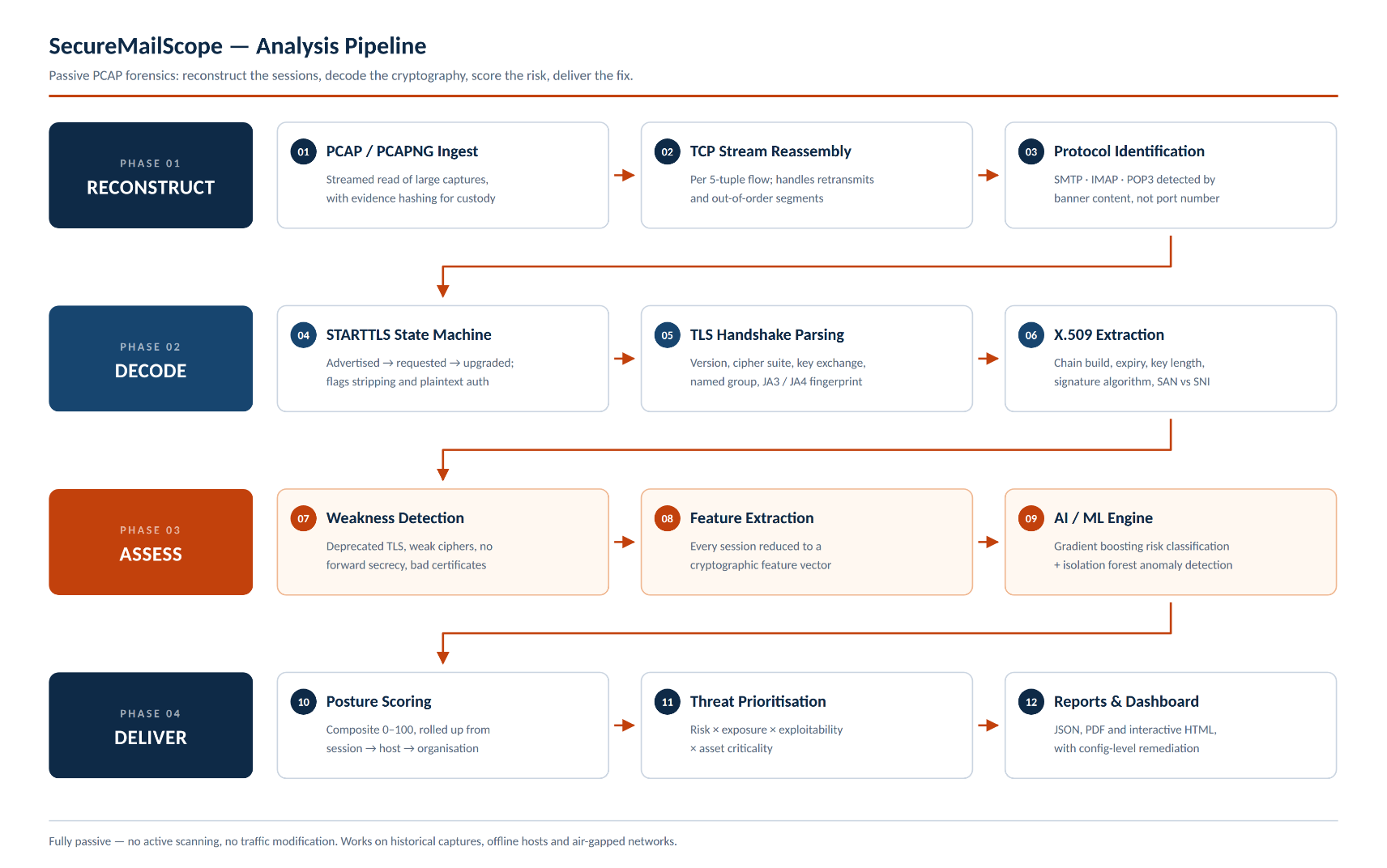
Ingest, TCP reassembly, protocol identification, STARTTLS state machine, handshake parsing, certificate validation, feature extraction, ML risk scoring and anomaly detection, prioritized findings, and JSON, PDF and dashboard export.
05 — TARGETS OF THE SOLUTION
Handles TLS 1.3 correctly, where certificates are encrypted and the true version hides in an extension. Detects stripping, along with encryption absence. Ranks by exposure and asset criticality, not severity alone. Returns config-level fixes mapped to NIST SP 800-52r2, PCI-DSS 4.0 and CERT-In.

